Objective 3: Conduct Hands-On Forensics Investigation of a Smart-Watch and Echo Dot Device
Note: This lab is a hands-on investigation of the acquisition, examination, and analysis stages of the forensic process. It is assumed that the identification and preservation of these devices was taken care of.
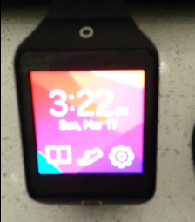
Identifying Files of Interest in a Smart Watch
Figure 1: Photo of Smartwatch
- IoT devices cover a wide range of electronics connected to the internet and receive, store, process and send information
- Device examined: Samsung Smartwatch (see Figure 1)
  - Can reveal daily routines, exercise habits, sleep patterns and movement timelines
  - Note: Browsed through all files and was unable to find OS version
    - However, the root folder was created on May 23, 2014, which could indicate when the device was bought and activated
- Lots of the data is never stored but can still find sensitive information useful to investigations
- FTK Imager: Used to explore disk images and recover artifacts without altering the original evidence
  - Creates forensic disk images to preserve evidence
  - Can browse folders and extract files to view through other applications
  - Able to go through file systems to locate user data, application databases, system configuration, and network artifacts
- Ext4: A file system associated with Linux and sometimes Android operating systems
- Media folder: Typically found on Android phones and extended storage devices like MicroSD cards used in Android phones
  - Contains synchronized media files and thumbnails generated by the smartwatch
- .thumb: A hidden folder containing thumbnails of photos and videos synched to the smartwatch
  - The extension refers to the file extension of the file that the thumbnail was created from
    - Ex. The images in here are the same images in the Images folder under Media folder
  - Here we can find thumbnails of the files that have been deleted
- DB Browser for SQLite: High quality, open-source tool to create, design, and edit database files with a spreadsheet-like interface
  - View and browse data through databases
  - Run SQL queries and export data
  - View databases to examine user accounts, communication records, application usage history, health data, and network information
- Most of the time-related data in a database needs to be converted from Unix Time to a readable date and time
- Examined the health database
- Took note of the timestamp of when the profile was created and the heart rate logs
  - This was the only profile found (see Figure 2)
Figure 2: Health Profile
  - The profile was created on March 17 at 7:07pm
  - There are 7 heart rate logs in total (see Figure 3)
  - All of the heart rate logs are normal and regulated
    - 2 logs on March 17 between 7:44pm and 7:53pm
    - 1 log on March 17 at 8:32pm
    - 2 logs on March 17 between 11:50pm and 11:51pm
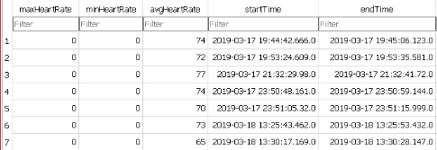
    - 2 logs on March 18 between 1:25pm and 1:30pm
Figure 3: Heart Rate Logs
  - These logs show that the smartwatch wasn’t worn consistently or the health tracking features were disabled during certain periods
  - These gaps can indicate when the device was inactive or removed by the user
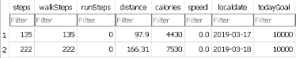
- Examined the pedometer history and logs (not a part of the lab) (see Figure 4)
Figure 4: Pedometer Logs
  - 115 steps on March 17 at 7:30pm
  - 20 steps on March 17 at 8:30pm
  - 15 steps on March 18 at 1:30pm
  - 207 steps on March 18 at 1:40pm
- No other information was found under the health database
- Examined the email database
  - hera13@mail.com is the only email registered to this device (see Figure 5)
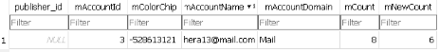
Figure 5: Email Account Registered
  - Looked email notifications of the user including date and time, titles, and messages (see Figure 6)
    - hera13@mail.com exchanged emails between 2 recipients, Zeus Smith (zeus1smith@gmail.com) and Hera Doe (hera9doe@gmail.com)
    - Based on the emails between hera13@mail.com and hear9doe@gmail.com, it’s possible that these are both Hera’s accounts
      - Can be used to send herself reminders, transfer files between devices, or write quick notes
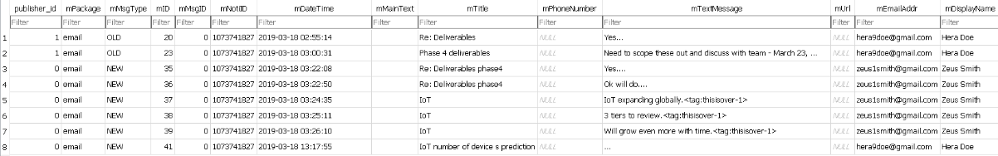
      - This could mean Zeus Smith is the only person the user communicated with
Figure 6: Email Notification Info
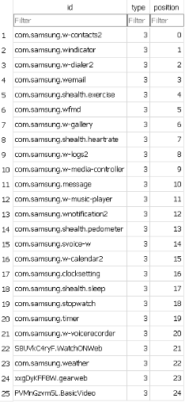
- Examined the favourite apps database
  - Looked through all apps on the device, sorted by most recently used (see Figure 7)
    - Contacts was the most recent app accessed, this could mean the user contacted someone before the device was examined
    - After looking through the contacts folder in the data folder, we see that there is only 1 contact saved
- Examined the contacts svc database (not a part of the lab) (see Figure 8)
- The last recorded phone call was made to Zeus on March 17 at 10:01pm, this means Zeus may know what Hera was up to before the device was examined
- The most phone calls also occur between Zeus and Hera at the same number (2148928643)
  - However, based on their emails, these may be work-related calls
Figure 7: Application Data
- All information can be used to determine normal behavioural patterns and distinguish where something is abnormal
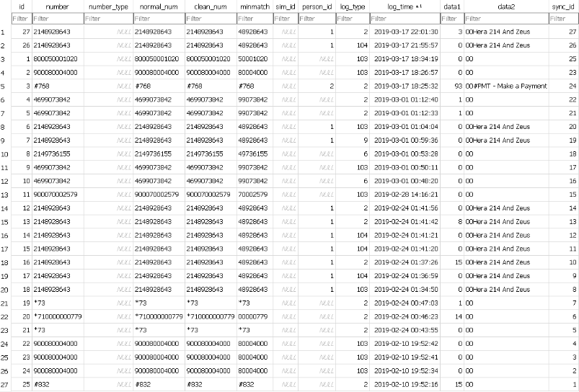
- Behavioural analysis based on smartwatch data
Figure 8: Phone Logs
  - The health logs and pedometer records show limited physical movement during the recorded time period
  - The user interacted with the Contacts app last before the device was examined
  - Emails and call records show regular communication with Hera Doe and Zeus Smith
    - Identifies who Hera had recent contact with and may have information regarding the investigation
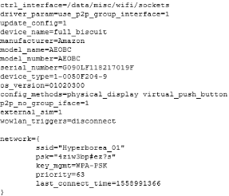
Identifying Files of Interest in an Echo Dot Device
- Amazon Echo Dot: smart home speaker that performs searches and controls other devices using voice commands
  - Stores a large amount of information that can be pertinent to forensic investigations
  - Configuration files and system logs identify wireless connections, authentication information, user accounts, and device configuration settings
Figure 9: WPA Supplicant Configuration
- Took note of the WiFI WPA supplicant info including last connected WiFi, the passphrase, key strength, and last connection made (see Figure 9)
  - Passphrase: A highly secure, memorable authentication secret; usually a sequence of 4-10 words including spaces, symbols and numbers
  - Info was stored in plaintext
    - Convenient because users tend to reuse passphrases for other services
  - WPA-PSK (WiFi Protected Access Pre-Shared Key): A security protocol for home/small office wireless networks
    - Authenticates users via a shared 8-63 character password instead of using an enterprise server
  - The network name and passphrase can associate a user to a specific WiFi router
    - Can provide the user’s specific location (if the router is stationary)
    - Can tell if the device was active
  - We can also see the manufacturer (Amazon) and the OS version (01020300)
    - Tells us which cloud infrastructure stores user data, shows the software environment and helps identify vulnerabilities
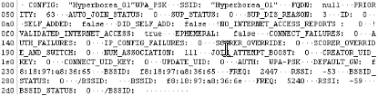
- Took note of network history including BSSID of the router, if the internet access was validated, authentication method and security protocol, MAC address of gateway, and MAC addresses of 1.4Ghz and 5Ghz BSSIDs (see Figure 10)
Figure 10: Network History
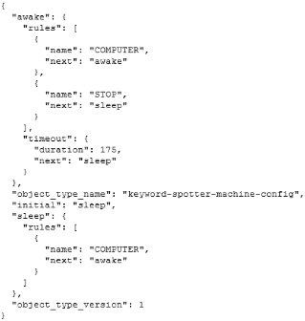
  - BSSID (Basic Service Set Identifier): A unique 48-bit MAC address of a specific WiFi access point or wireless radio
  - The MAC addresses of the BSSIDs will reveal the location of the device along with the user
- Took note of the op.cfg.json file under the wakeword folder (see Figure 11)
  - Shows the voice commands of the device
  - Typically records metadata associated with voice interactions (the lab did not provide any voice command logs)
  - In a real investigation, this allows investigators to determine when voice commands were used and what actions the device did
Figure 11: Voice Commands
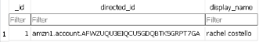
- Examined the data storage database and found the account name of the user (see Figure 12)
Figure 12: User Account
  - This is the name linked to all of the data storage found on the device, Rachel Costello
  - This is the only account linked to the device
  - This metadata shows the locale as en-US, which means it is in Canada or the US

